Project name
Climate Envelope Models for 26 Threatened and Endangered Florida Vertebrates
Publisher
The Croc Docs, University of Florida
Project manager
James Watling
Publication Date
10/16/2012
Contact
watlingj@ufl.edu

Project Information
Climate envelope models (CEMs) were created to delineate areas of climate suitability for 26 Threatened and Endangered Florida vertebrates. The grid resolution used to create our models was 0.167 decimal degrees, and we applied the geographic projection datum WGS 1984. All models were converted to NetCDF format and can be seen with the spatial data viewer software EverVIEW (http://www.jem.gov/Modeling).
One NetCDF file was created per species, which compiles 16 CEM files or ‘variables’ displaying climate suitability projections for the years 2010 (contemporary conditions) and 2060 (future conditions). Contemporay climate was described as the average of conditions from the WordClim (http://www.worldclim.org/) and Climate Research Unit (http://www.cru.uea.ac.uk/en) data sets. Future conditions include three general circulation models (HADCM3, NCAR CCSM3 and GFDL2.0) and two CO₂ emissions scenarios (IPCC scenarios A1B and A2). Data for the period 2041—2060 were averaged and reported as 2060 data. Projection climate data were obtained here: http://ccr.aos.wisc.edu/resources/data_scripts/ipcc/index.php.
There are two formats available for all contemporary and future projections maps: continuous probability and binary ‘presence/absence’. Continuous probability maps have names with the suffix “_probability” and they display a species’ suitable areas in a continuous score from 0 to 1, where areas with values closer to 1, indicate higher climate suitability for the species. Binary maps’ have names with a “_classified” suffix and display a map with areas that are either suitable or not. Binary maps are a product of the probability maps, in which a numeric threshold was calculated in a species per species basis according to our modeling procedures (See table 1), and any probability score above the threshold indicates a suitable area, while a probability score below it represents a non-suitable area.
Projection maps for future conditions were created using two IPCC emission scenarios (A1B and A2) and three global climate models (GCMs). The three GCMs chosen were GFDL, NCAR and UKMO. Therefore, each species’ NetCDF file contains 12 future projection maps given all possible permutations (type of GCM, emission scenario, and probability/binary format).
Additionally, two ‘Consensus’ maps for future predictions were created to visualize where the three GCMs ‘agreed’ on their predictions (one for scenario A1B and another for A2).
To summarize, each species’ NetCDF file contains:
- 2 contemporary projection (2010) variables
- 12 future projection (2060) variables
- 2 future consensus variables

Figure 1 – Example of the Crocodylus acutus NetCDF file loaded into Everview. By clicking on the ‘Variable’ field, one can choose which of the 16 CEMs variables will display in the EverVIEW world map
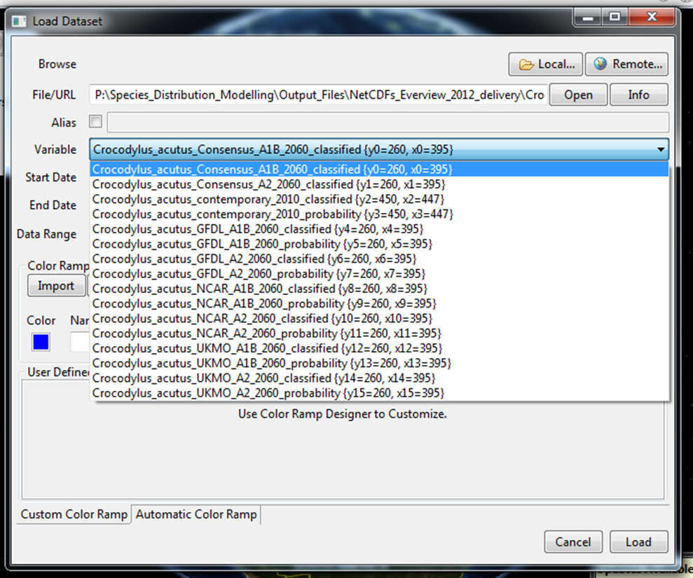

Uploading Instructions
For a general instruction on how to upload NetCDF files, refer to EverVIEW’s main window’s menu Help > Help contents > EverVIEW Data Viewer > Loading Datasets. It is important to note that since our maps do not represent an exact time period with an exact day, month and year, they were labeled as ‘atemporal’. The atemporal format disables an interoperability option in EverVIEW that allows the user to scan among the different variables in the NetCDF file. In order to see the different variables in the NetCDF file, the loading process has to be redone every time by loading the NetCDF and then the desired variable. It is recommended to use more than one globe session in order to see more than one variable at a time.
Pre-made, custom color ramps (.xml format) have been created for the map legends for the probability, binary and consensus maps. These customized color ramps allow users to display the data in the maps more clearly and it also makes the map’s legend more understandable. They can be downloaded from the http://crocdoc.ifas.ufl.edu/projects/climateenvelopemodeling/ at the bottom of the page. Once they are saved in a folder, go back to EverVIEW’s ‘Loading Dataset’ window, and after selecting the desired variable from the list, click the ‘Load’ button in the ‘Color Ramp Designer’ section. Go to the folder where the .xml files were saved and select the corresponding color ramp to whichever type of map you would like to display (probability, continuous, or consensus) and press the Open button.

Further modifications to some of the original CEMs
Considering the coastal nature of the species Crocodylus acutus, Microtus pennsylvanicus dukecampbelli, Nerodia clarkii taeniata, Oryzomys argentatus, Peromyscus polionotus niveiventris, Peromyscus polionotus phasma, and Sterna dougalli dougalli, their original projections of climate suitability were modified to only show areas 2 kilometers away from coastal areas.
In the case of the species Grus americana, only occurrences that represent their nonmigrotory populations were used for the models, given that those are the populations that are considered to be endangered.

Table 1 - Binary Maps’ Thresholds by Species
Ambystoma cingulatum | 0.14
Ammodramus maritimus mirabilis | 0.26
Ammodramus savannarum floridanus | 0.19
Aphelocoma coerulescens | 0.16
Charadius melodus | 0.32
Crocodylus acutus | 0.17
Drymarchon corais couperi | 0.34
Eumeces egregius lividus | 0.26
Eumops floridanus | 0.18
Grus americana | 0.34
Microtus pennsylvanicus dukecampbelli | 0.09
Mycteria americana | 0.35
Neoseps reynoldsi | 0.14
Neotoma floridana smalli | 0.15
Nerodia clarkii taeniata | 0.01
Odocoileus virginianus clavium | 0.09
Oryzomys argentatus | 0.07
Peromyscus gossypinus allapaticola | 0.14
Peromyscus polionotus niveiventris | 0.08
Peromyscus polionotus phasma | 0.07
Picoides borealis | 0.34
Polyborus plancus audubonii | 0.06
Puma concolor coryi | 0.3
Rhostramus sociabilis plumbeus | 0.29
Sterna dougallii dougallii | 0.12
Sylvilagus palustris hefneri | 0.19

